 | YEAR 12 ATAR PHYSICS Unit 4  PRACTICAL TEST 2018 5.0%  NAME: ………………………………………………….  Others in the Group: …………….……………………………..  Data: See Data Sheet  Approx. marks shown.  (50 marks)

When calculating numerical answers, show your working or reasoning clearly. Give final answers to three significant figures and include appropriate units where applicable.
When estimating numerical answers, show your working or reasoning clearly. Give final answers to a maximum of two significant figures and include appropriate units where applicable.

BACKGROUND:
When gases are placed in a tube and subjected to a high-voltage electric discharge, the electrons in the atoms can be excited to higher energy levels within the atoms; when they return to their original levels electromagnetic radiation is emitted. Some of this radiation may be in a wavelength region that is visible to the human eye.
To measure these wavelengths in the laboratory, we must first separate them. To the naked eye, the various wavelengths (colours) of light emitted by an element are mixed together and appear as a single colour that is a combination of the component colours. If we view the light through a diffraction grating, however, the individual wavelengths are separated. A diffraction grating is a piece of glass or clear plastic with many very narrow and closely spaced lines on it. As the light emerges after being diffracted by the grating, these tiny lines cause the diffracted light to interfere with itself in such a way that the different wavelengths of the light to appear in different positions to the left and right of the original direction in which the light was traveling. See the figure below.
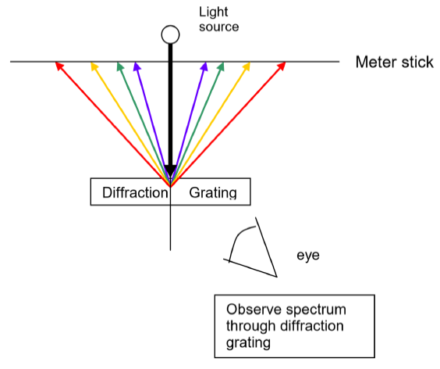
In this experiment mercury is placed in an electric discharge tube and a high voltage is placed across the tube. The excited mercury emission looks almost white, but it is in reality composed of a number of different colours or wavelengths of visible light. You will use a diffraction grating to allow you to separate the different wavelengths in the visible region. The position of these lines will be measured. There is also some emission in the ultraviolet region, but the human eye can’t see it.
After using the mercury data you will then examine the spectrum of helium and calculate the wavelengths of the visible part of this spectrum. Finally you will find the line spacing of the grating.
Part A Collecting the Data: Completed as a group of a maximum of 3 students.

AIM: To measure the position of the emission spectrum lines of mercury vapour and helium.

APPARATUS: Lamp holder and high voltage power supply
    - Mercury discharge lamp and Helium discharge lamp
    - 600 lines/mm Diffraction grating in a stand so that grating is at the same height as the centre of the Mercury discharge lamp
    - 2 x Meter rulers
    - Thin pointer

METHOD:
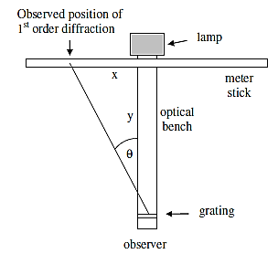
Figure 1.Experimental Setup for the Observation of Mercury Vapour Line Spectra
Safety: You should not look directly at the mercury discharge light coming from the slit in the mercury lamp. When you observe the spectra, you will be looking at an angle to the lamp, but you should not stare directly at the lamp.

Figure 1 illustrates the basic setup - use two meter rules to measure the distances x and y,

- Set the metre rules on the bench. Be sure the two are exactly perpendicular to each other and that the bench rule is aligned at cross rule at the 50 cm mark.
- Place the mercury lamp in the holder.
- Put the grating on its support and place it about 75 cm from the mercury discharge tube. Record the position y. The top of the grating is marked on the grating, and it should be positioned so that the top is highest above the optical bench.
- One lab partner will view the emission spectrum of mercury vapour by looking through the diffraction grating at an angle from one side and observing the yellow, green and violet lines at a position on the other side of the mercury discharge lamp.
- The other partner will stand behind the mercury discharge lamp and move a thin pointer along the meter stick to the position described by the observer. Record the position where the yellow, green or blue image appears in Table 1.
- This procedure should be repeated for each of the yellow, green and violet lines by two different students. Record this in Table 1.
- Average the two x measurements of each spectral line by each observer.
- Place the helium lamp in the holder. Repeat steps 4 to 6. Record this in Table 2.

RESULTS:
y = ……….. cm [1]

Table 1 Mercury vapour:
Line colour | Line wavelength  λ (nm) | x (cm)
 |  | Observer 1 | Observer 2 | Average
yellow | 571
green | 546
violet/blue | 436
[4]

Table 2 Helium:
Line colour | Line wavelength  (nm) | x (cm)
 |  | Observer 1 | Observer 2 | Average
red
yellow
green
violet/blue
[4]

Part B Calibration of the emission spectrum of helium; completed as an individual.

AIM: To use the emission spectrum of mercury to calibrate the emission spectrum of helium.

PROCESSING OF RESULTS:

1. For the mercury vapour data, plot a graph of λ (nm) on the y-axis against Average x (cm) on the x-axis on the graph paper on the next page. Draw the line of best fit. [4]

- (a) Determine the gradient of the graph. Show your working clearly. [3]

(b) Write the equation of the line of best fit. [2]

………………………………………………………..

- Use the answers to Q 2 to calculate the wavelengths of the visible part of the helium spectrum and record these in Table 2. Show your working of ONE of the calculations in the space below. [3]

Working:

 | YEAR 12 ATAR PHYSICS Unit 4  PRACTICAL TEST 2018 5.0%  NAME: ………………………………………………….  Others in the Group: …………….……………………………..  Data: See Data Sheet Approx. marks shown.

When calculating numerical answers, show your working or reasoning clearly. Give final answers to APPROPRIATE significant figures and include appropriate units where applicable.

Part C Determining the grating spacing; completed as an individual.

AIM: To use the emission spectrum of mercury and helium to determine the line spacing of the diffraction grating, d, in nm. [This is the same as the distance between the slits in the 2 slit interference patterns studied in class.]

In this part of the experiment you will use the different spectral lines of excited mercury vapour and helium to calculate the angle of diffraction of each line. The relationship between the wavelength, the line spacing and the diffraction angle is
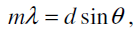
where m is the order of diffraction (you can only see the first order, so m = 1),
λ is the wavelength of the spectral line in nm, and
θ is the angle of diffraction.

PROCESSING OF RESULTS:
- From pg 3 transfer the values of y, the values of Average x (cm) and wavelength to Table 3.

- From Figure 1 calculate the value of the angle θ for each spectral line, and hence sin θ. Record these in Table 3. Show your working of ONE of the calculations in the space below. [5]
Working:

Table 3 y = ……….. cm
Line colour | Line wavelength  λ (nm) | Average x (cm) | θ (°) | sin θ
Mercury
yellow | 571
green | 546
violet/blue | 436
Helium
red
yellow
green
violet/blue
3. Plot a graph of λ (nm) on the y-axis against sin θ on the x-axis on the graph paper below. Draw the line of best fit. [4]

- (a) Determine the gradient of the graph. Show your working clearly. [3]

(b) Write the equation of the line of best fit. [2]

………………………………………………………..

- (a) Use the answers to Q 4 to calculate the line spacing of the diffraction grating, d, in nm. Show your working in the space below. [3]

(b) For a diffraction grating of N lines per mm, the line spacing is calculated by

$$Line spacing= \frac{1}{N} in mm$$
- Calculate the line spacing in nm of the diffraction grating used in the experiment.
[2]

- Compare this value with that obtained in Q5 (a) above. How close are the values? [3]

QUESTIONS
- Measurement of the position x of the mercury vapour emission lines was repeated for each of the yellow, green and violet lines by two different students.
- Why was the measurement repeated? [1]

…………………………………………………………………………………………………….

…………………………………………………………………………………………………….

- Why was the measurement repeated by two different students? [2]

…………………………………………………………………………………………………….

…………………………………………………………………………………………………….

- Suggest another method that could be used to repeat the measurement.
[Hint: Consider pg 1.] [2]

…………………………………………………………………………………………………….

…………………………………………………………………………………………………….

…………………………………………………………………………………………………….

…………………………………………………………………………………………………….

- What would be the effect on the position x of the mercury vapour emission lines if the diffraction grating were placed 100 cm from the lamp instead of 75 cm from the lamp? Explain. [2]

…………………………………………………………………………………………………….

…………………………………………………………………………………………………….

…………………………………………………………………………………………………….

…………………………………………………………………………………………………….

End of Test

